1. **Configure smtp in localhost**

Install the package ssmtp --> SMTP , mailutils --> Mail package

Using command sudo apt -y packagename

Edit the file name nano/etc/ssmtp/ssmtp.conf"

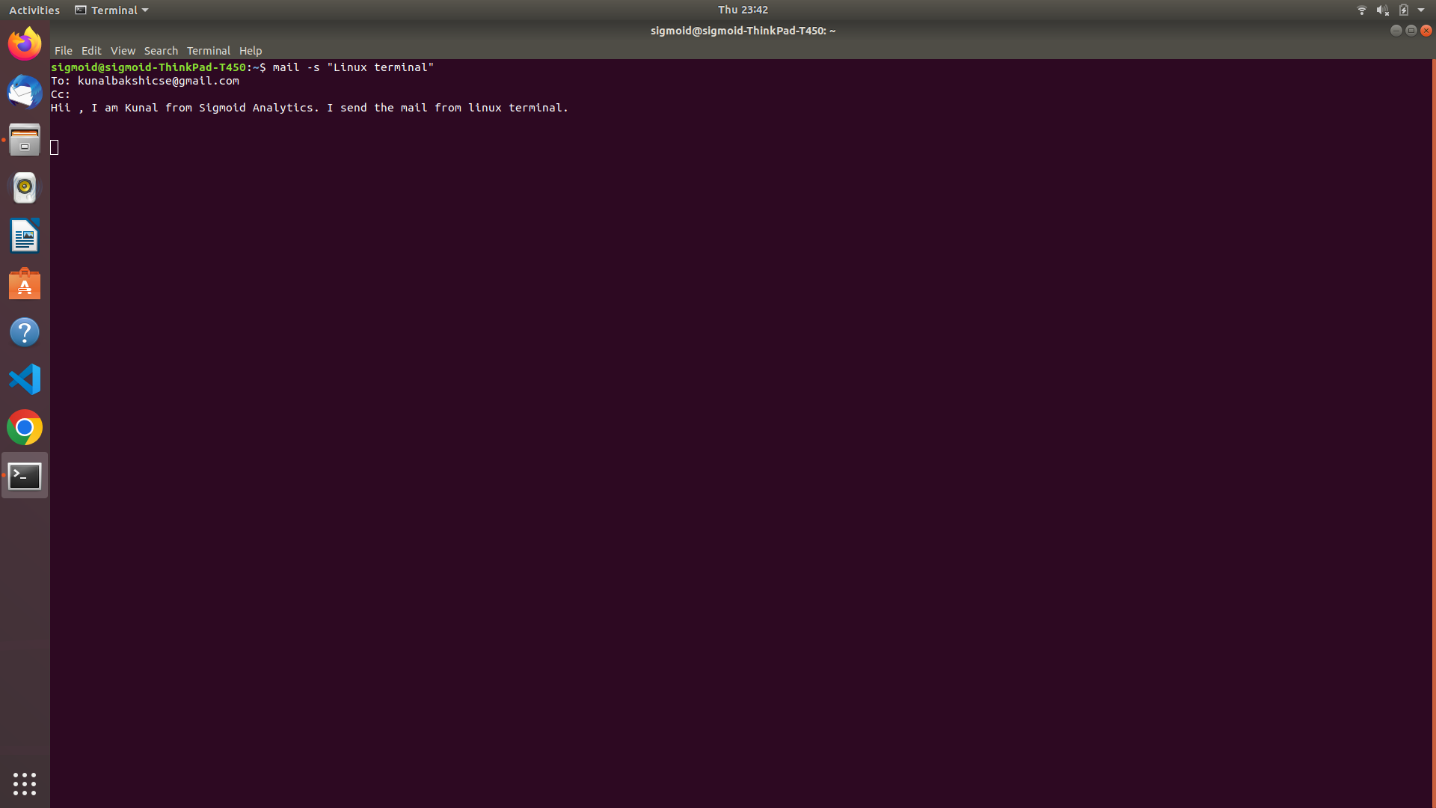**s**

1. **Create a user in your localhost, which should not be able to execute the sudo command.**

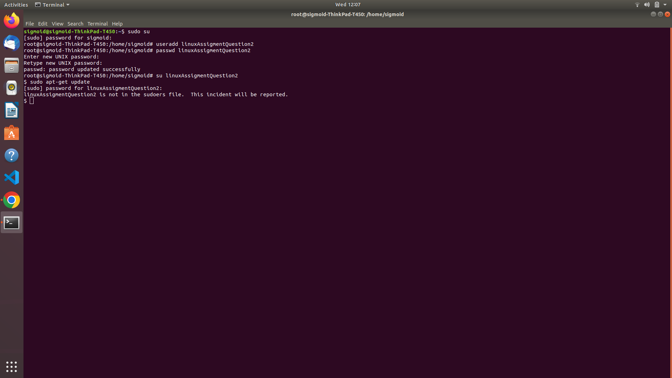

1. **Configure your system in such a way that when a user type and executes a describe command from anywhere of the system it must list all the files and folders of the user's current directory.**

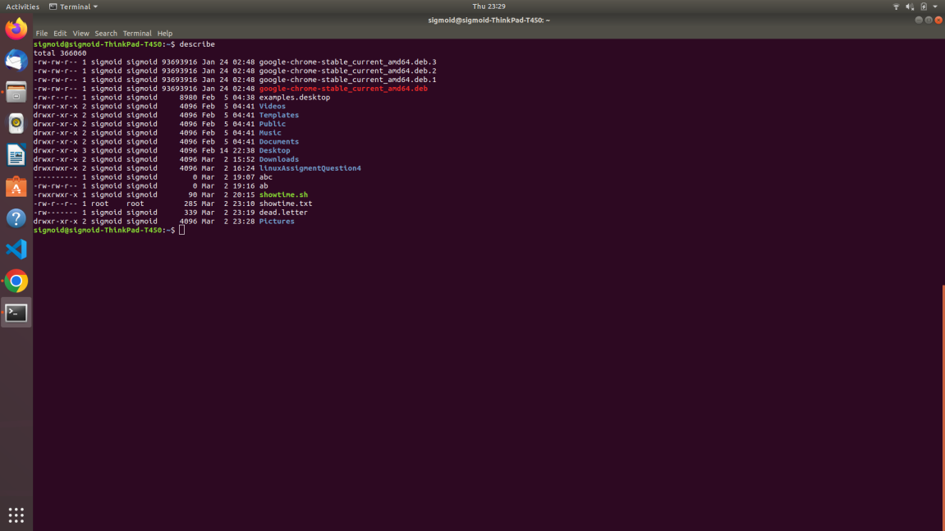

1. **Users can put a compressed file at any path of the linux file system. The name of the file will be research and the extension will be of compression type, example for gzip type extension will be .gz.**

**You have to find the file and check the compression type and uncompress it.**

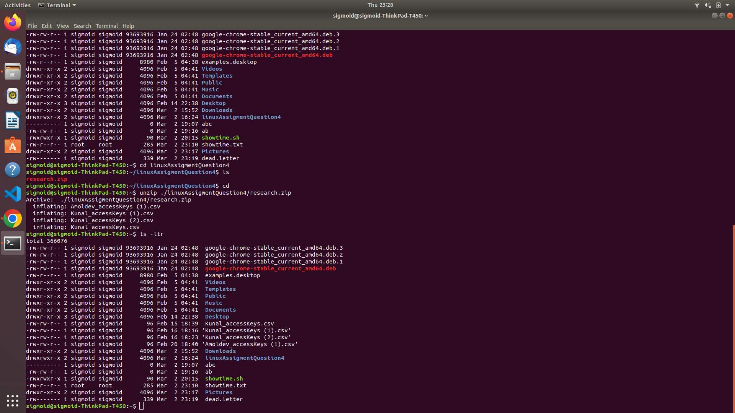

1. **Configure your system in such a way that any user of your system creates a file then there should not be permission to do any activity in that file.**

* First go to the root. cmd-"sudo su"
* Then go to the .bashrc file and open in editor. cmd-"nano /etc/bash.bashrc.
* Afterthat at the bottom of the file write "umask u-rwx,g-rwx,o-rwx" and save that file
* 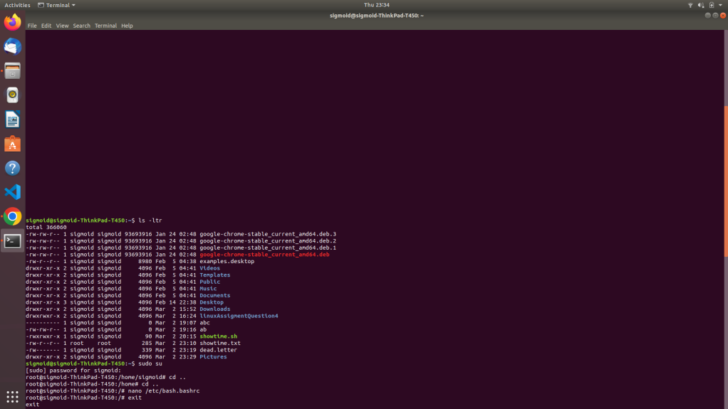

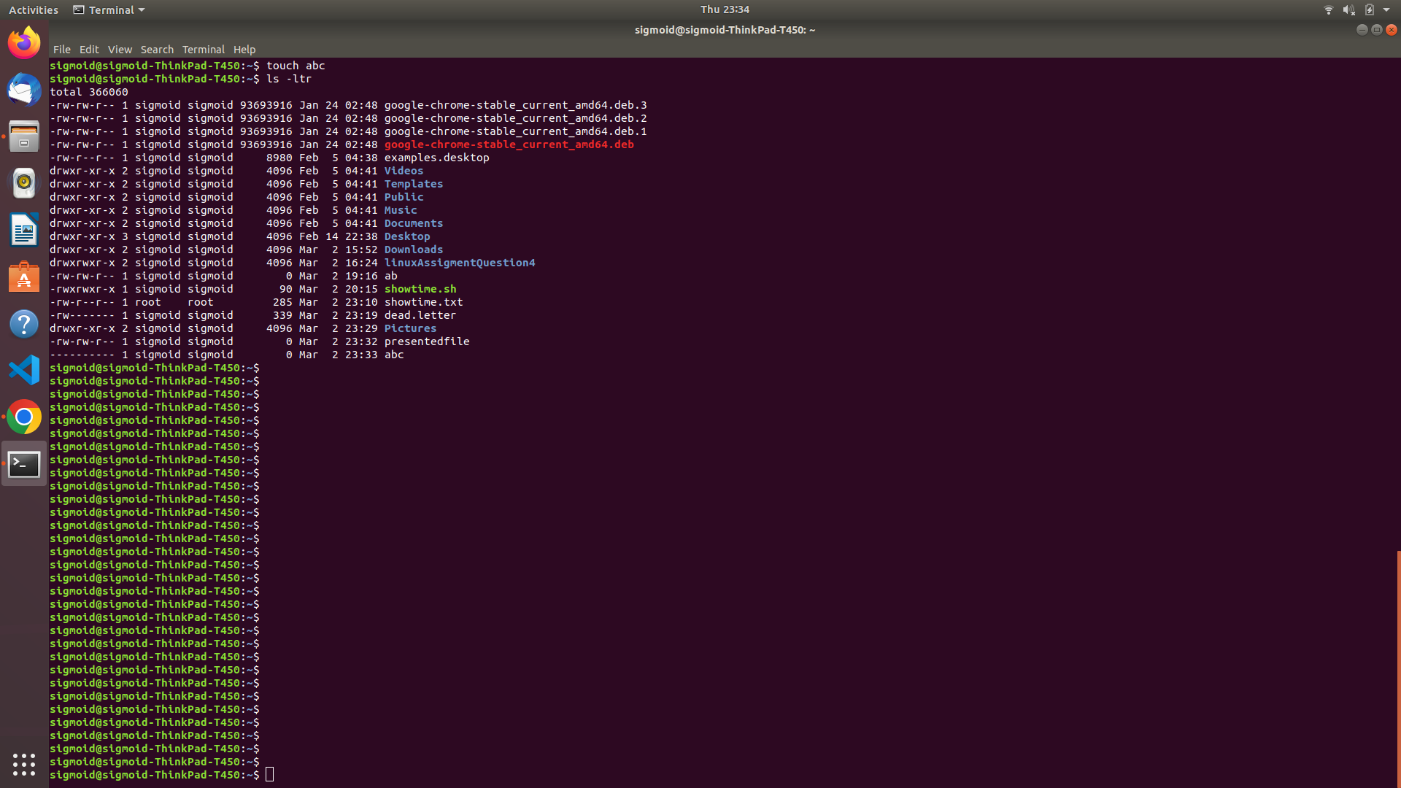

1. **Create a service with the name showtime , after starting the service, every minute it should print the current time in a file in the user home directory.**

* First we have to create a file using. cmd-"touch filename.sh".
* Then we will write a script inside that to write you can use nano or vi editor. cmd-"nano filename.sh" or ex-"vi filename.sh"     script:-         #!/bin/bash         while true         do         echo $(date +%T) >> /home/sigmoid/showtime.txt         sleep 30                 done.
* Afterthat we will convert that file into executable file. cmd-"chmod +x filename.sh"
* Then we will create a service file. cmd-"touch filename.service"
* Now we will write that executable filepath into this service file.     script:-         [Service]         ExecStart=/home/sigmoid/showtime.sh
* Afterthat we will move that file to '/etc/systemd/system' path. cmd-"mv filename.service /etc/systemd/system/"
* Then to start the service. cmd-"sudo service servicename start"
* To stop the service. cmd-"sudo service servicename stop"
* To show to status. cmd-"sudo service servicename status"

